Week Six: Trends in Adult Learning Settings
Felicia L. Jones-Shaw
AET/500
July 28, 2014
Dr. Deborah Hornsby

Week Six: Trends in Adult Learning Settings
July 28, 2014

World Financial Services
One Lunsford Drive
Atlanta, GA 30034

Felicia L. Jones-Shaw
Director of Communications & Change Management
Sales and Marketing
World Financial Services
One Financial Drive
New York, NY 10034
Dear Ms. Jones-Shaw:
I understand the future trends in sales and marketing, as well as how our organization can continue to add financial value to our customers, are concerns that continue to be on your priority list. With the advancement of technology, increased use of the Internet, and the growing presence of social media, it is important that, as educators, we continue to explore opportunities that will allow World Financial Services to stay abreast of the changes in our industry and implement training programs and practices that aid our employees in showing our customers how we can help them take control of their finances.
As we know globalization, technological advances, and consumer access to copious amounts of information on the Internet, has created a situation in which people are overloaded with numerous financial products and services they are told will meet their everyday needs. However, with more than five decades of experience, and our award-winning track record in providing the highest customer satisfaction among U.S. financial corporations, I’m positive the information shared in this document will help us show our staff why and how we can continue to set ourselves apart from the competition.
Recently, I was presented with The Association for Talent Development’s (ATD), formerly ASTD, launch of their new ASTD Competency Model. By capturing the changes driven by important factors such as the ones I previously mentioned and others, including demographic shifts and economic forces, this new model redefines the skills and knowledge needed to be successful today, and going into the future. The ASTD Competency Model emphasizes two key components: 1) Foundational Competencies, and 2) Specific Areas of Expertise (AOE). As presented in Figure 1, there are ten competencies that make up this model.
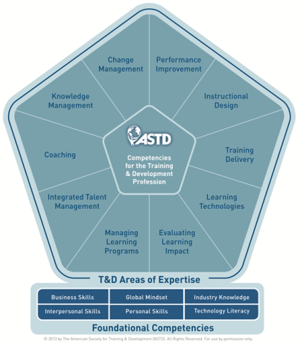
Figure 1 - © 2013 by The American Society for Training & Development (ASTD). All Rights Reserved.
The competencies presented in this model are important for educators of any profession. They guide us in describing and improving organization performance through training and development activities; and, help us identify the knowledge, skills, and behaviors our learners need to be successful performers. ASTD provides us with Table 1 as an outline about each competency.
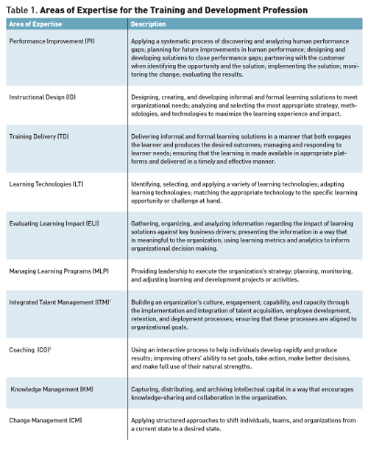
Table 1 - © 2013 by The American Society for Training & Development (ASTD). All Rights Reserved.
As educators, we can use The ASTD Competency Model to create balance in adult learning by using strategies that are going to engage and challenge learners based upon their experiences and needs. In addition, the model aids educators in creating learning environments that allow learners to freely express their thoughts and ideas, as well as ask questions and accept the training provided so they perform successfully in the roles for which they have been hired. When we set a climate that is cooperative in nature, we allow students to learn for themselves, but have guidance and support from us when needed.
While it is important to create a learning environment that is safe, hands-on, and non-threatening, we also must make sure we know our audience. The more we learn about our students’ backgrounds and learning needs, the more efficient and effective we become as educators. This includes learning more about their language, culture, values, family, and home environment. This knowledge will help us to better support our students in the classroom; and, know what type of support and challenges our learners face outside the classroom. As an educator, knowing who your audience is, why they are participating in the learning process, and the conditions needed to enhance their learning experience is vital to our success as educators (Merriam, Caffarella, & Baumgartner, 2007, p. 53). As Cunningham points out, “Socially responsible adult educators need to become aware of the social as well as personal dimensions of learning and the capacity of education to respond” (Merriam, Caffarella, & Baumgartner, 2007, p. 71).
In today’s society, now that social media and technology have become conventional modes of informal communication, we can incorporate many activities, such as creating infographs, blogs, using social media sites like LinkedIn, etc., into our classrooms to gain knowledge about our students. I think it is a good idea to ask them about their backgrounds, how they learn best, what was their best experience with an educator, and then their worst. Currently, we use Live Meeting, or Adobe Connect, and have small breakout sessions so that we don’t just get to know our students, but they also gain knowledge about one another. One thing I love to do when I have them breakout into smaller groups is have them learn about one another, and then they choose a speaker to present the information to the group. I rotate things around throughout the course so that, eventually, everyone has presented in my class. I will also have them do team presentations where they may have to research a topic or product and then present it back to the group as a whole. I incorporate role plays and other activities where I am not always talking at them, but they are sharing in the learning process. My goal is to do enough activities and research that gives me the insight to how my students perceive and process information. By doing the activities that I listed, I don’t just get to know my learners, but they also get to know me.

In formal settings, educators have become fond of Think-Pair-Share, a collaborative learning strategy developed by Frank Lyman and his colleagues in Maryland. It is low-risk because it helps learners stay focused on the content being presented, which also helps to prevent off-task thinking and behavior. Accountability is built in as each learner takes responsibility for their feedback and actions.
For example, an instructor poses a question, and then provides time for learners to think about the subject matter individually (Think). The instructor then asks learners to discuss the subject matter with a partner (Pair). Finally, the instructor invites the group to come back together and participate in a whole-group discussion of the subject matter (Share).
This learning strategy can be used for various subjects before, during, and at the end of instruction. It engages students individually, in pairs, and as a class as they think about a topic or answer to a question posed by the instructor. In addition, the structure provided by this learning activity helps to eliminate the problem of only the most verbal students participating in a discussion.
In regards to ethics and values as they pertain to the adult learner, I like to rely on the twelve-point “Bill of Rights for the Adult Learner.” Published on February 21, 1991 by the Board of Directors of the Coalition of Adult Education Organizations, they state “institutions and agencies of a democratic society should strive to assure the following rights are possessed by all who have adult responsibilities and who seek to learn in any setting (p. 104):
- The right to learn regardless of age, gender, color, ethnic or linguistic background, marital status, the presence of dependents, disability or financial circumstances.
- The right to equal opportunity for access to relevant learning opportunities throughout life.
- The right to educational leave from employment for general, as well as vocational or professional, education.
- The right to financial aid and educational services at levels comparable to those provided for younger or full-time learners.
- The right to encouragement and support in learning subject matter that the learner believes will lead to growth and self-actualization.
- The right to a learning environment suitable for adults to include appropriate instructional materials, equipment, media and facilities.
- The right to have relevant prior experiential learning evaluated and, where appropriate, recognized for academic credit toward a degree or credential.
- The right to participate or be appropriately represented in planning or selecting learning activities in which the learner is to be engaged.
- The right to be taught by qualified and competent instructors who possess appropriate subject-matter knowledge, as well as knowledge and skills relating to the instructional needs of adults.
- The right to academic support resources, including instructional technology, that can make self-directed or distance learning possible.
- The right to dependent care and related structures of social support.
- The right to individualized information and guidance leading toward further study.”
Walt Disney once said, “If we can dream it, we can do it.” I want my students to know that with hard work, belief in themselves, and self-discipline, their dreams can become a reality.
My goal as an instructor is to help learners think independently and critically. I want my students to learn how to learn for themselves, and not be afraid to challenge the information being presented to them. I would like for them to share their opinions, but also be respectful and supportive of ideas presented by their peers. Learners should be able to communicate efficiently and effectively with others, whether verbally, visually, or in writing, as well as appreciate diverse subject matter.
As an educator, my role is to guide my students in the learning process and self-discovery, as well as to inspire and empower them to learn outside the classroom. I want to teach learners to discover the world for themselves, realize their talents, respect others, and share their knowledge so they, and our world, continue to evolve, and they are successful in their careers.
Sincerely,
Felicia L. Jones-Shaw
Vice President, Training and Development
World Financial Services

rss
Enclosure
cc: Abraham T. Gathers

The American Society for Training & Development (ASTD). (2013). The ASTD Competency Model. Retrieved from http://www.astd.org/Certification/Competency-Model.aspx
The American Society for Training & Development. (2013, January 10). Training and Development Competencies Redefined to Create Competitive Advantage. Retrieved from http://www.astd.org/Publications/Magazines/TD/TD-Archive/2013/01/Training-and-Development-Competencies-Redefined?mktcops=c.career-development~c.workforce-development~c.human-capital~c.learning-and-development&mktcois=c.career-development-2-subtopic~c.competencies~c.career-planning~c.human-performance-improvement~c.training-and-development
Merriam, S., Caffarella, R., & Baumgartner, L. (2007). Learning in adulthood: A comprehensive guide. (3rd. ed.). San Francisco, CA: Wiley & Sons.
Lyman, F. (1981). The responsive classroom discussion: The inclusion of all students. In A. Anderson (Ed.), Mainstreaming Digest (pp. 109–113). College Park, MD: University of Maryland Press.
Jarvis, P. (2005). Adult Education and the State: Towards a Politics of Adult Education. New York, NY: Routledge.
Please note that the names, job titles, and organizations in this business letter are fictitious (excluding Felicia L. Jones-Shaw, Atlanta, Georgia, and New York, New York). The information herein has been created for course purposes only. The World Financial Services logo has been created exclusively for the purposes of this assignment and is not affiliated with any company or organization.

